Technical Report of the Titanic Dataset

Histogram of Numerical Column(Age) :

This Histogram provides insight into the age of the passengers aboard the Titanic. This shows that most passengers were young adults, with the number of passengers steadily declining among older age groups..A histogram was chosen because it effectively displays the distribution of a wide range of ages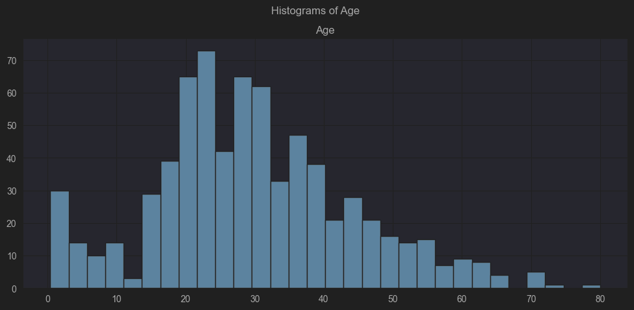

Pie Chart of Categorical Data(Survived):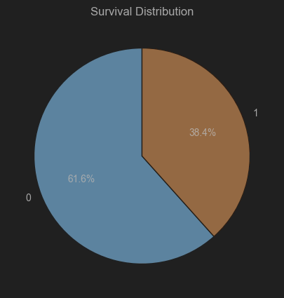

The pie chart shows the distribution of the passengers that died or survived the crash of the Titanic. IIn the data, a value of 1 indicates survival, while 0 indicates that the passenger did not survive. A pie chart was used because it clearly expresses the proportion of passengers who survived versus those who did not.

Scatter Plot with Linear Regression (Fare vs Pclass):

The scatter plot shows a negative correlation between fare and passenger class, where first-class passengers paid significantly more than third-class passengers. However, the low R-value indicates that passenger class alone does not fully predict fare variations, suggesting other factors also influence fare prices.. A scatter plot was used because it shows the regression line.

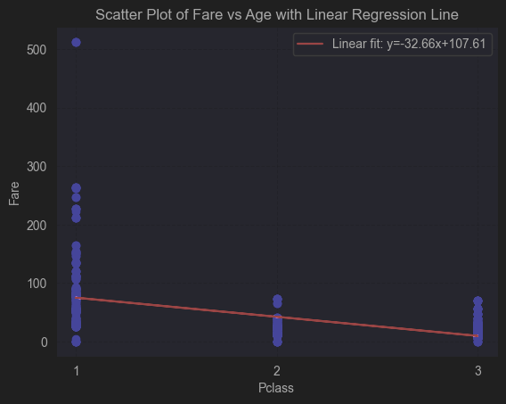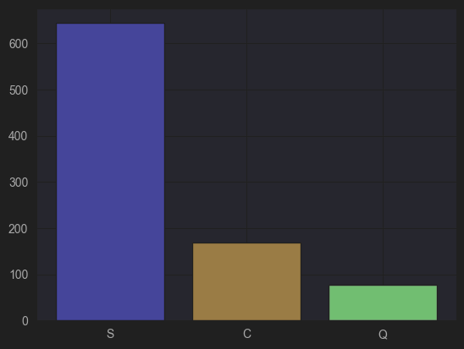

The bar chart shows the number of passengers who embarked from each port. Southampton(S) had the highest number of passengers, followed by Cherbourg(C) and Queenstown(Q). A bar chart was chosen because the data categories are limited, making it a more suitable and clear option than a histogram.

Contingency Table and Chi-Square Test: Survival vs Pclass:

Chi-square statistic: 102.88898875696057

P-value: 6.258462423531468e-20

The chi-square test yields a p-value of less than 0.05, which indicates a significant association between survival and passenger class. One possible inference is that first-class passengers may have received priority access to lifeboats and assistance during the evacuation..

Summary:

A histogram shows that most of the passengers were young adults with a steady decline as age increases. A pie chart shows that a majority of the passengers on the Titanic died.The scatter plot between fare and passenger class shows a negative correlation, indicating that first-class passengers paid significantly higher fares.. However, the R-value suggests that other factors besides class influence fare prices.. Bar chart shows that most passengers left from Southampton. The chi-square test and contingency table reveal a significant association between passenger class and survival, indicating that first class passengers got priority when it came to life boats and assistance.